**1. User Registration**

**Endpoint:** POST /register  
**URL:** <http://localhost:5000/register>  
**Description:** Registers a new user.  
**Screenshot :**

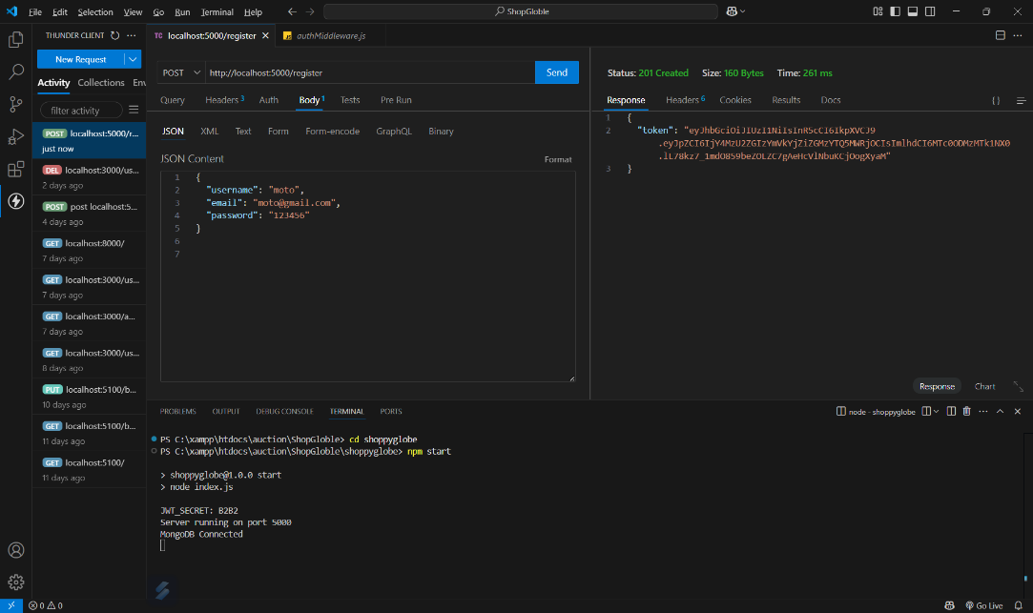

**2. User Login**

**Endpoint:** POST /login  
**URL:** <http://localhost:5000/login>  
**Description:** Authenticates a user and returns a JWT token.  
**Screenshot:**

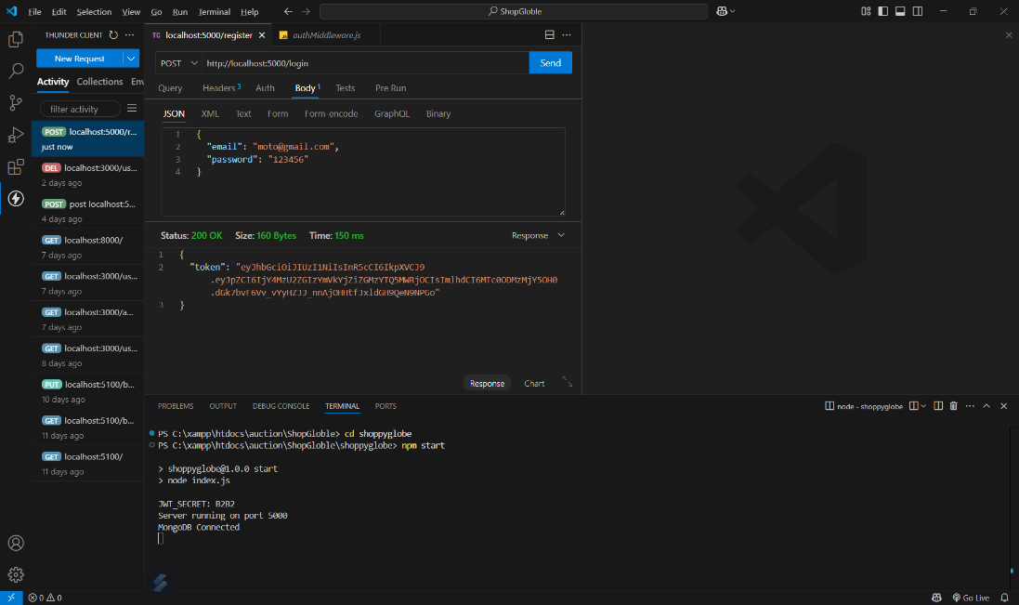

**3. Get All Products**

**Endpoint:** GET /products  
**URL:** <http://localhost:5000/products>  
**Description:** Fetches a list of all products.  
**Screenshot :**

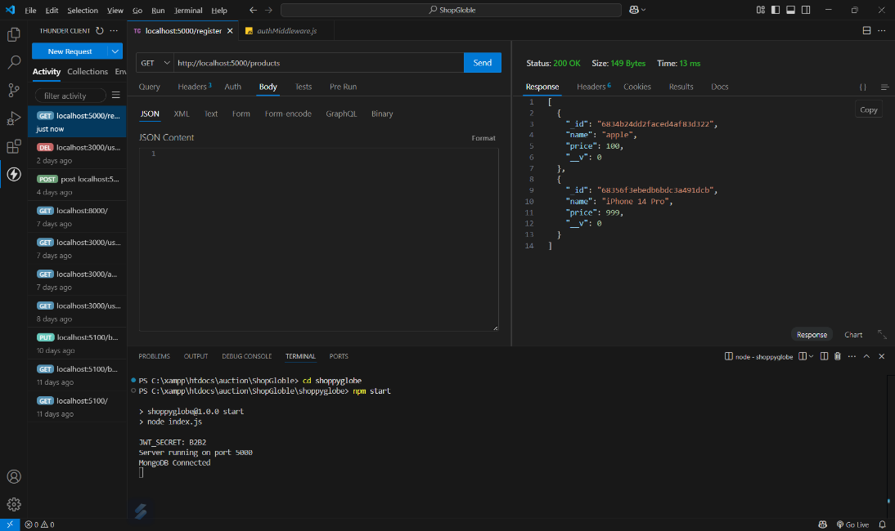

**4. Get Product by ID**

**Endpoint:** GET /products/:id  
**URL:** [http://localhost:5000/products/{product_id}](http://localhost:5000/products/%7Bproduct_id%7D)  
**Description:** Fetches the details of a single product by ID.  
**Screenshot :**

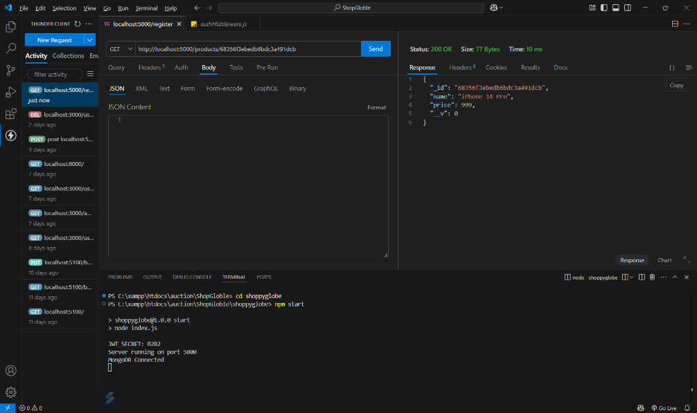

**5. Add to Cart**

**Endpoint:** POST /cart  
**URL:** <http://localhost:5000/cart>  
**Headers:** Authorization with Bearer JWT token required  
**Description:** Adds a product to the authenticated user’s shopping cart.  
**Screenshot :**

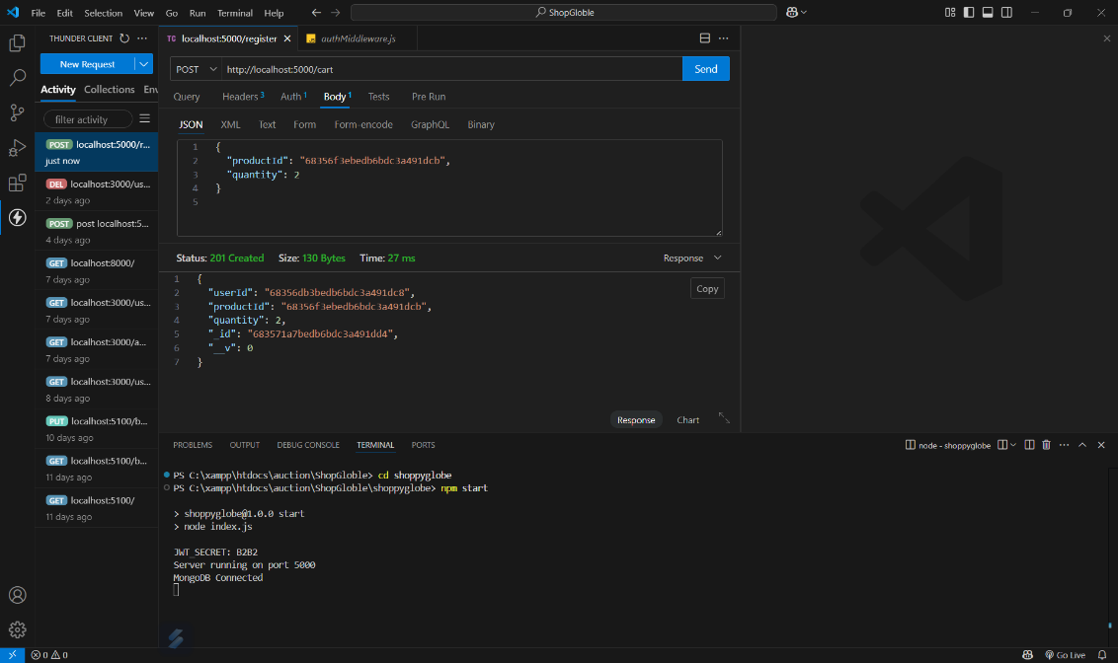

**6. Update Cart Item**

**Endpoint:** PUT /cart/:id  
**URL:** [http://localhost:5000/cart/683571a7bedb6bdc3a491dd4](http://localhost:5000/cart/%7Bcart_item_id%7D)  
**Headers:** Authorization with Bearer JWT token required  
**Description:** Updates the quantity of a product in the cart.  
**Screenshot :**

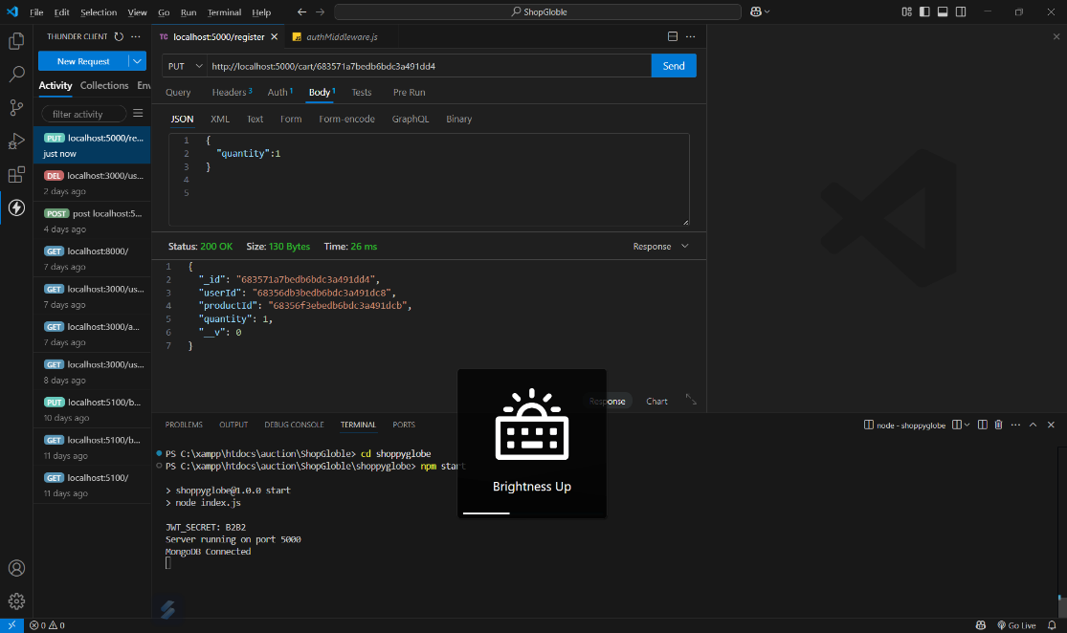

**7. Delete Cart Item**

**Endpoint:** DELETE /cart/:id  
**URL:** [http://localhost:5000/cart/683571a7bedb6bdc3a491dd4](http://localhost:5000/cart/%7Bcart_item_id%7D).  
**Headers:** Authorization with Bearer JWT token required  
**Description:** Removes a product from the cart.  
**Screenshot :**

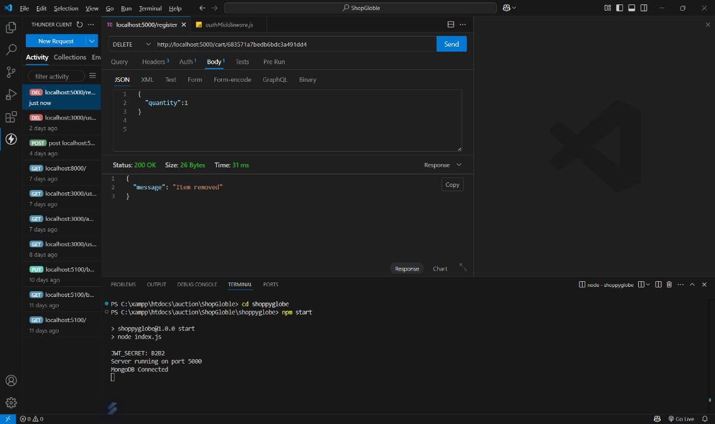

**MongoDB Collections**

**Description:** Screenshots of MongoDB Compass showing collections used in the project.  
**Required Collections:**

* Users collection

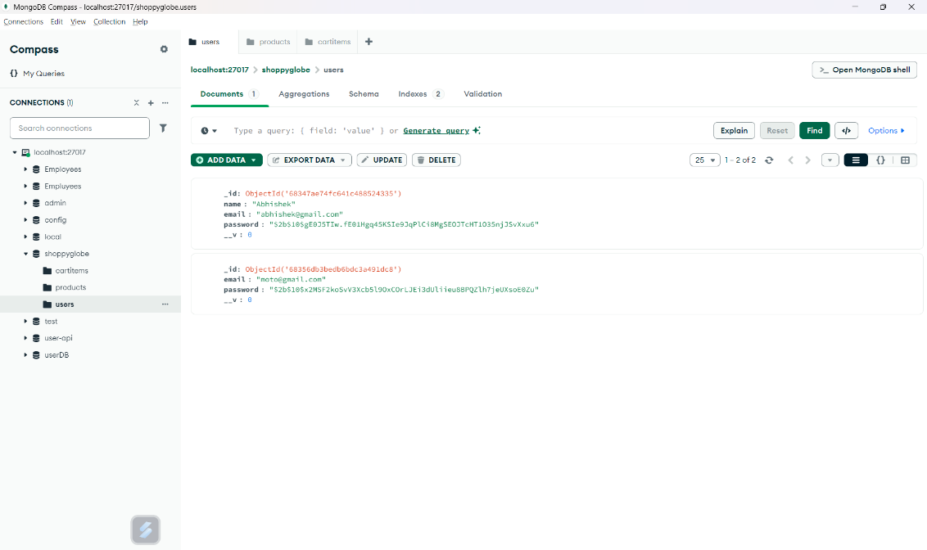

* Products collection

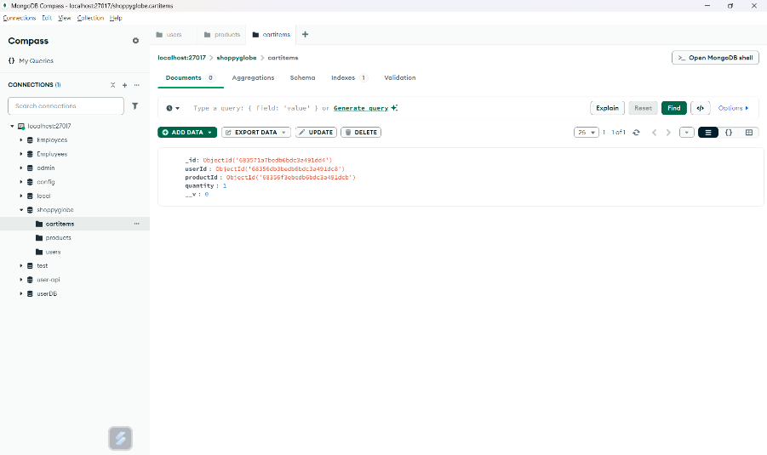

* Cart collection

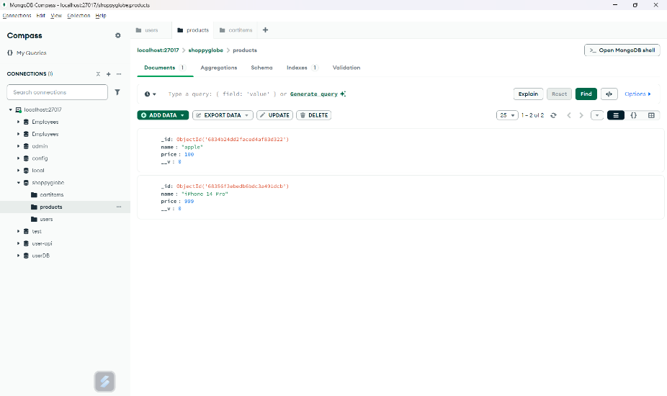

* Delete

